Registering Patients in CDMS

Your patients will register via a link that you will distribute that directs them to your clinic to choose their appointment.

Information for Patients registering via weblink:

- Your patients will click the link you provide to them either via a web browser or cell phone. *Note the registration site is smart phone compatible.
- Patients will select the appointment time that works for their schedule from the open appointments from the schedule that was loaded into CDMS.
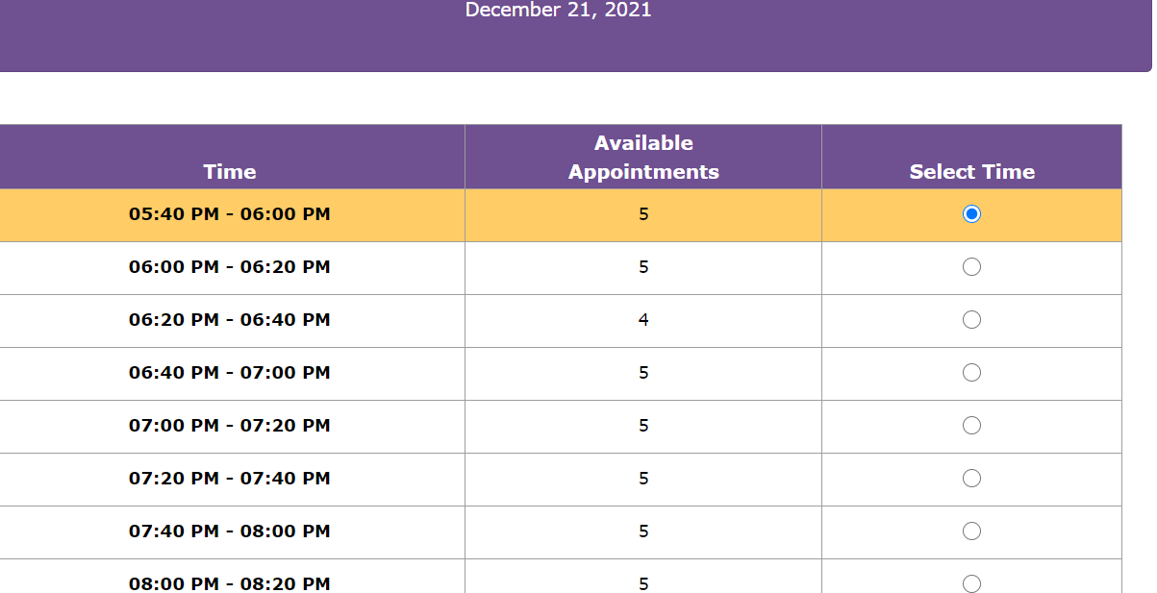
- Patients will then provide their demographic information into the system and answer the question to either consent or not to a COVID-19 vaccination. *Note, anything with an optional next to it is not mandatory to be filled in.
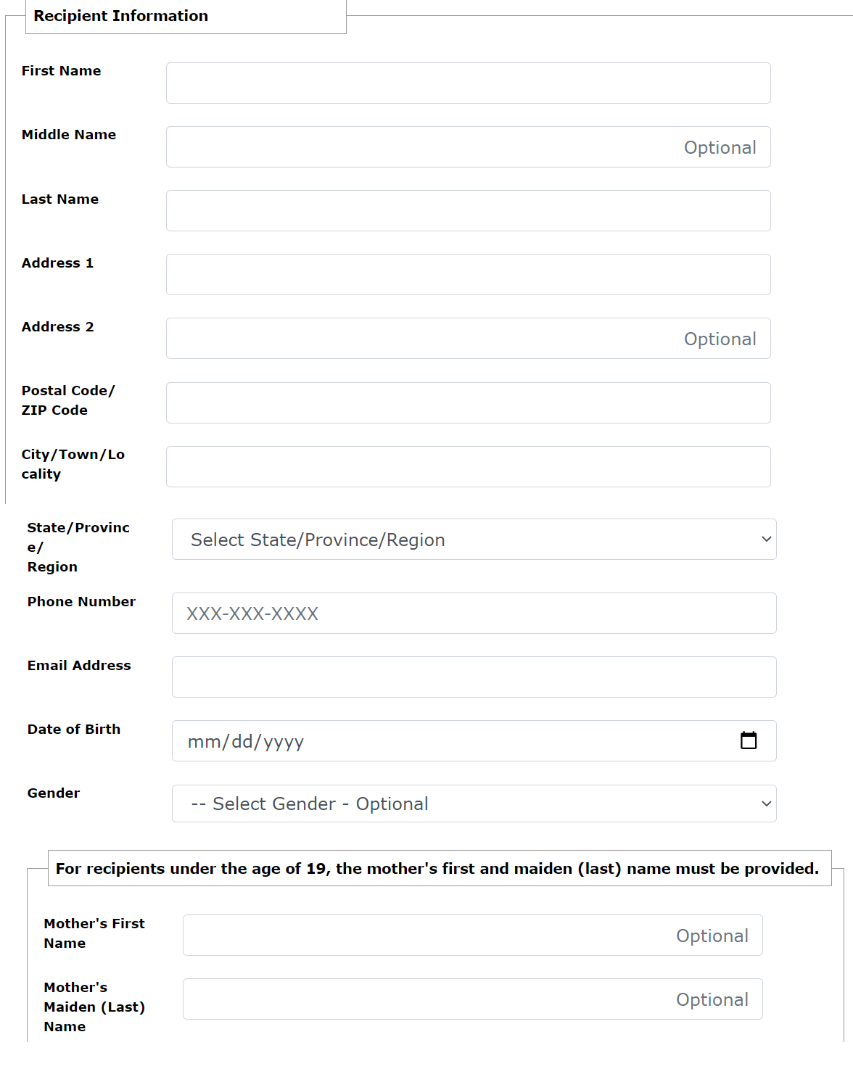
- Patients will be brought to a review page to change any information if needed
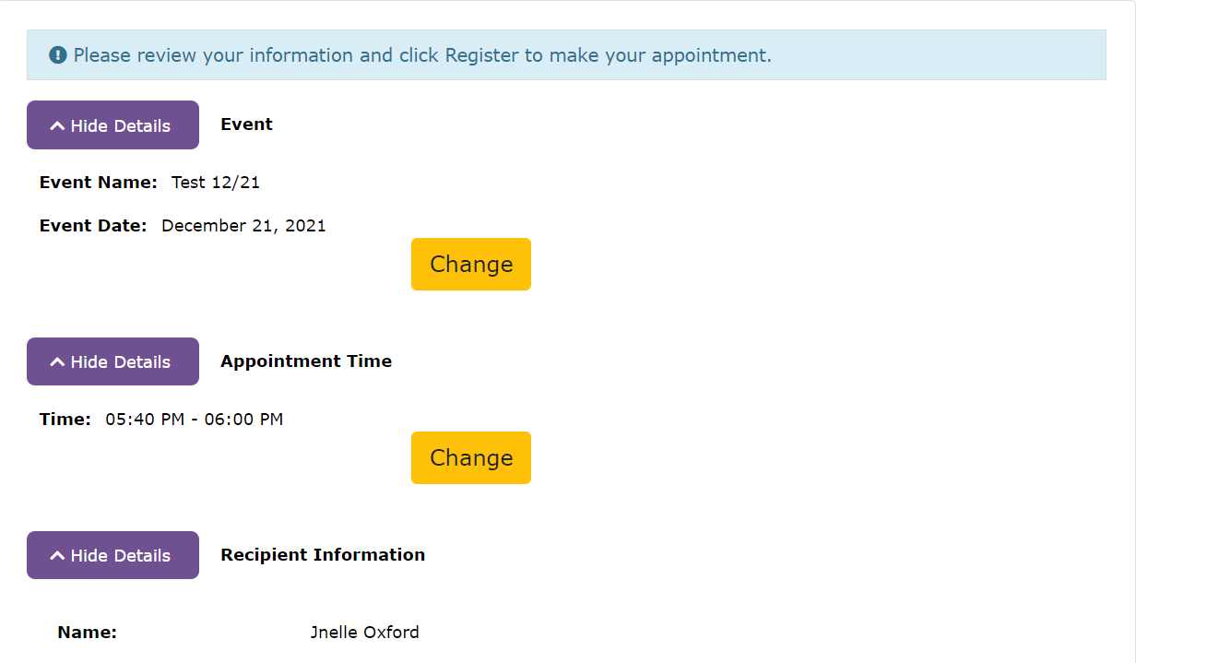
- They will scroll and click ‘Register’
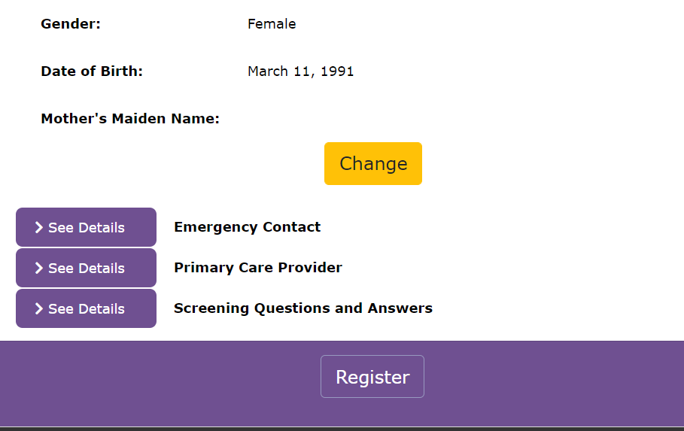

- Patients will then go to the final screen where they can print their ticket and then will finish off by clicking done. *Note, the ticket will also be emailed to the address they provided.

