**How to Create Reports in CDMS**

**Facility Admin** role has access to General Reports

**General Reports** include these 4 reports:

* Recipient Demographics - Attendees Grouped by Operation
* Recipient - All Data
* Recipients Scheduled
* Registration - Recipients No Show

**General Reports:**



**Instructions for Generating Reports:**

1. 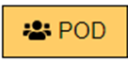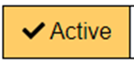From the Home screen, click on 'Reports,' and select 'General.' From the report screen, select and
2. Select the appropriate options in the **Event Name, Form Name, and Operation Name** fields. The 'Select All' option may be used to generate reports providing data from multiple variables.
3. Enter the **Start Date** and **End Date** for the report by using the 'Date Range' sliding scale bar or manually entering dates in the provided fields.
4. Select the desired report from the available options in the **Report Name** field and click the 'Run Report' button.
5. The Report Results Section at the bottom of the screen will show report results. The report generated may be exported to an **Excel** spreadsheet by clicking on the green spreadsheet icon found on the right of the screen just above the Report Results Section.

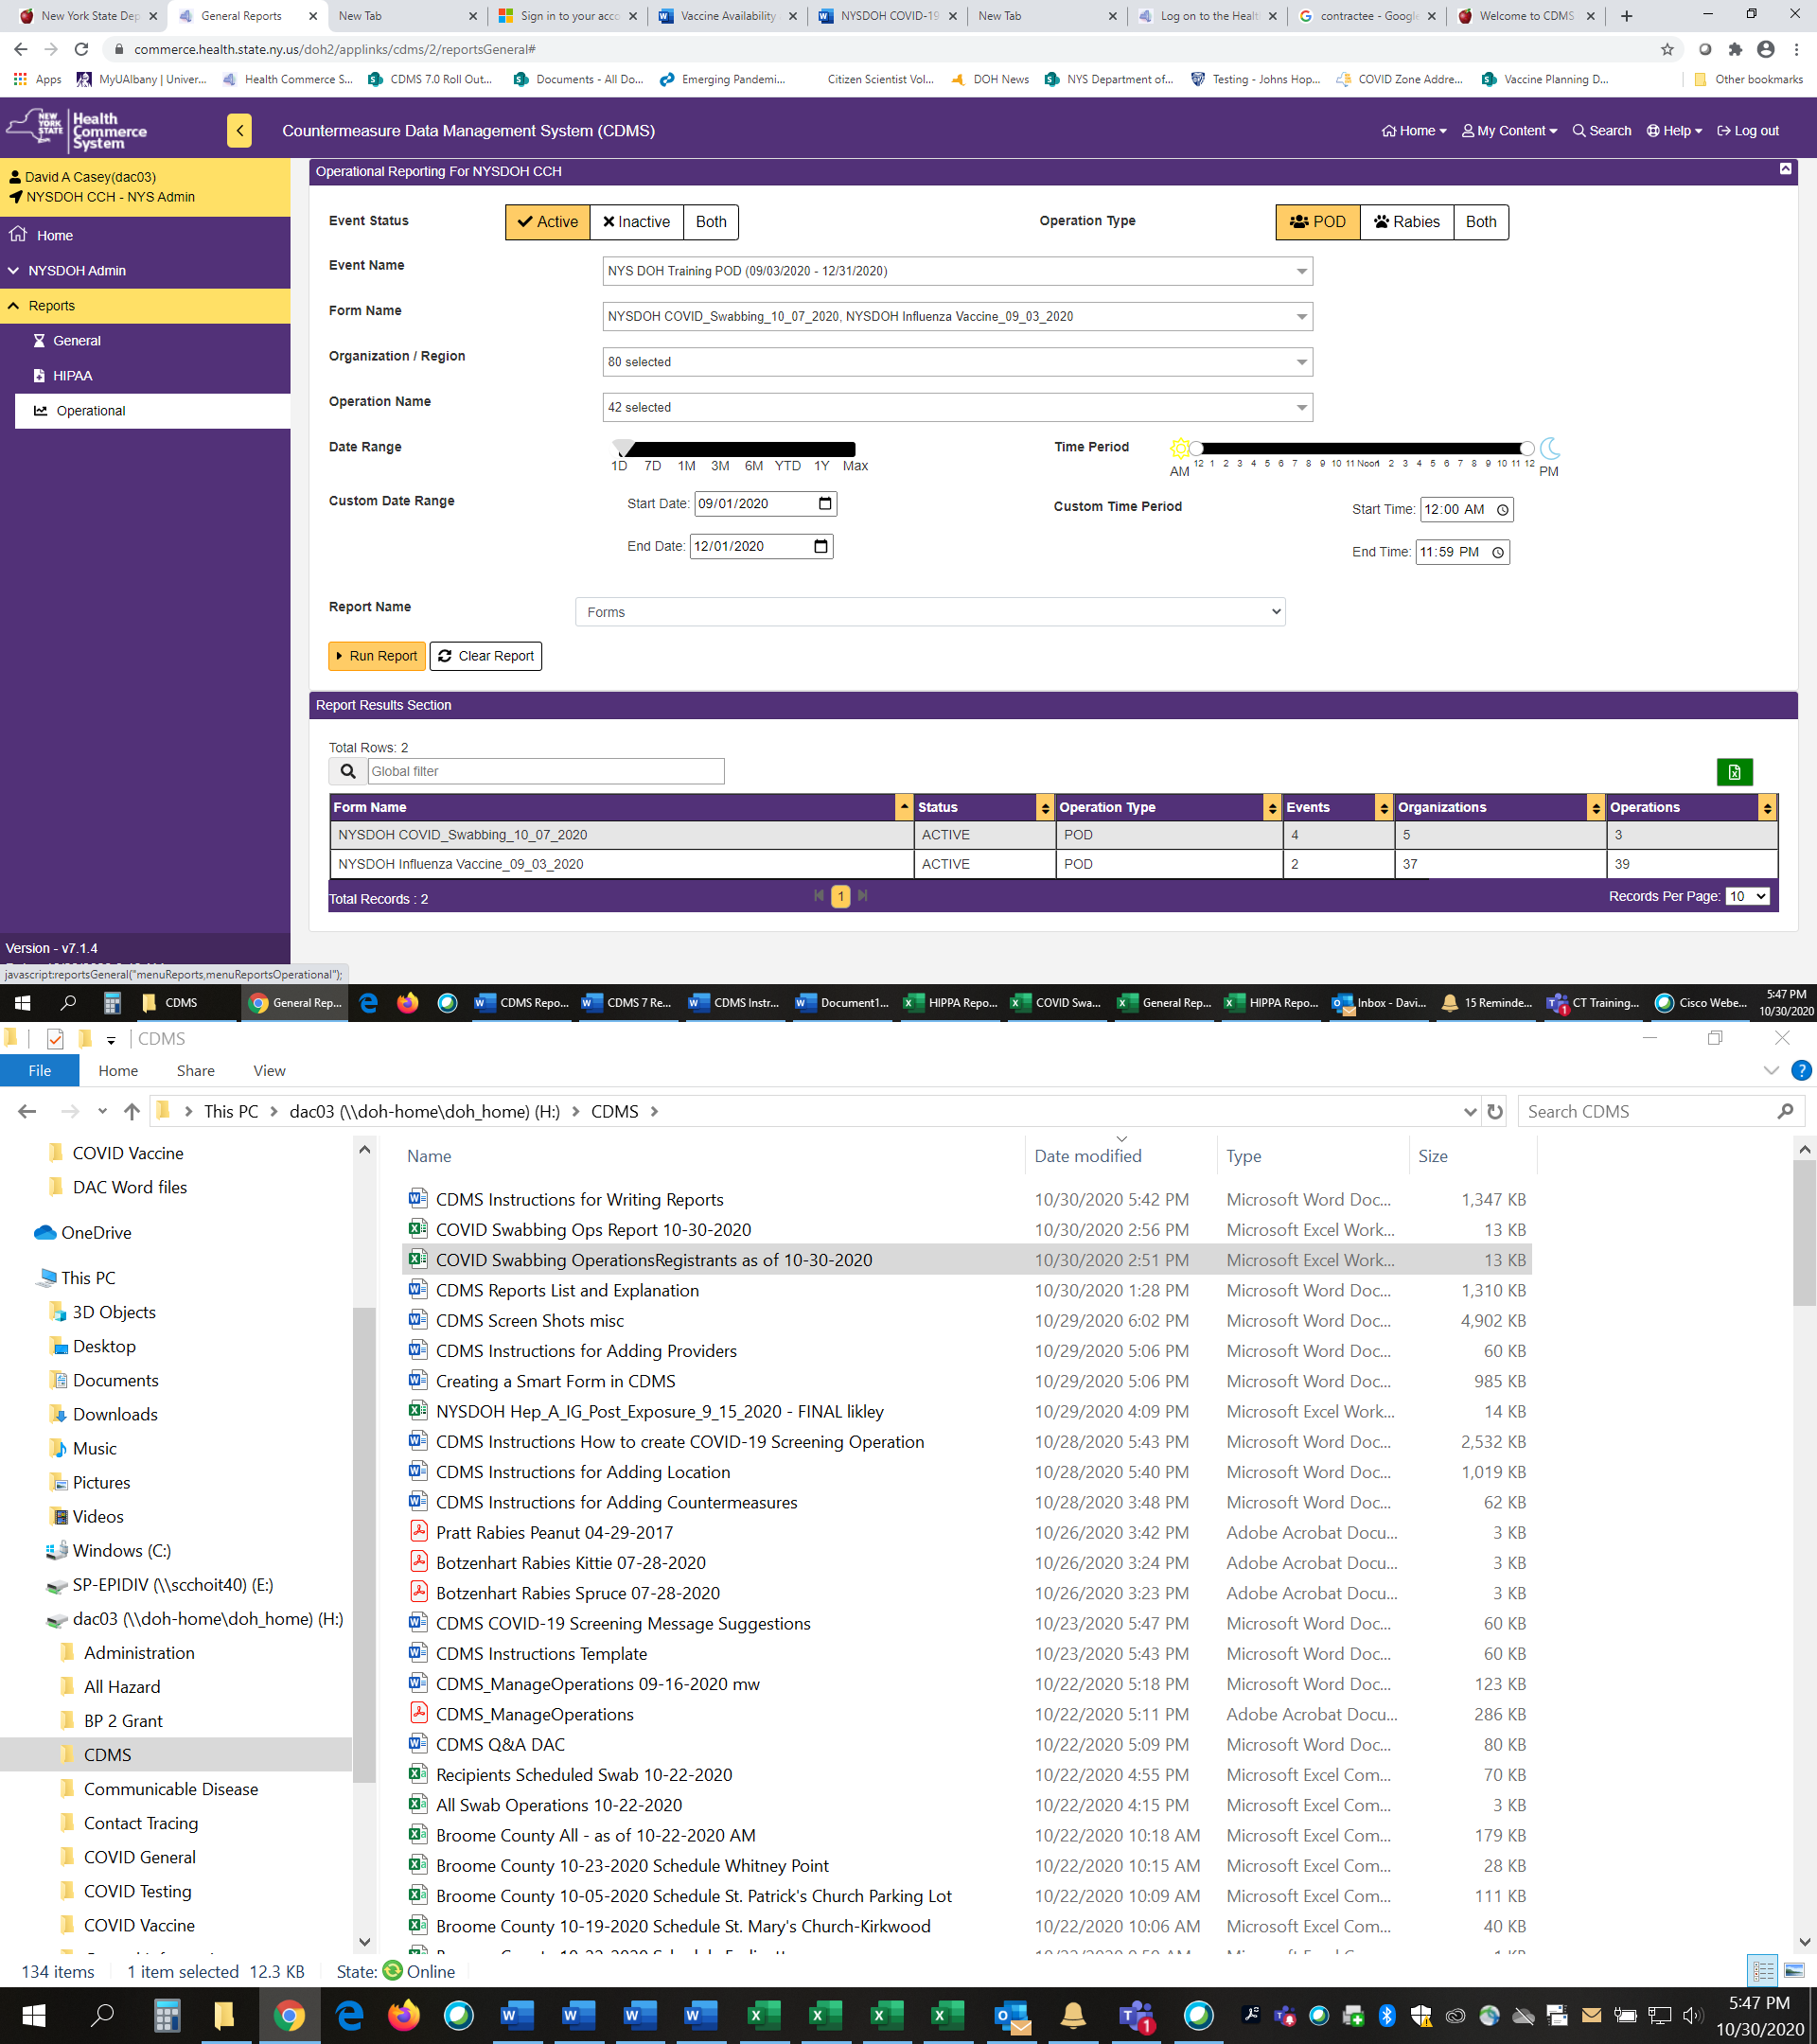

Click green spreadsheet icon to export to Excel.

**Data Availability for Reports:**

|  |  |  |
| --- | --- | --- |
| **General Report Name** | **Able to Run BEFORE Operation** | **Able to Run AFTER Operation** |
| Recipient Demographics - Attendees Grouped by Operation | **Limited** | **Yes** |
| Recipient - All Data | **No** | **Yes (Recipient ID only; HIPPA compliant)** |
| Recipients Scheduled | **Yes (scheduled only, no cancellations)** | **Yes (not processed only)** |
| Registration - Recipients No Show | **Yes (scheduled + cancelled)** | **Yes (cancelled + not processed)** |

**General - Recipient Demographics - Attendees Grouped by Operation:**

|  |  |  |  |  |  |  |
| --- | --- | --- | --- | --- | --- | --- |
| Event Name | Form Name | Organization/Region | Operation Name | Recipients | Deferred | Medical Evals |

**General - Registration - Recipients Scheduled:**

|  |  |  |  |  |  |  |
| --- | --- | --- | --- | --- | --- | --- |
| Event Name | Form Name | Operation Name | Registration ID # | Recipient Name | Appointment Date | Appointment Time |

**General - Registration - Recipients No Show:**

|  |  |  |  |  |  |  |  |
| --- | --- | --- | --- | --- | --- | --- | --- |
| Event Name | Form Name | Organization/Region | Operation Name | Registration ID # | Recipient Name | Date | Time |

**General - Recipient - All Data:**

|  |  |  |
| --- | --- | --- |
| Event Name | Recipient County | CM Administration Site1 |
| Form Name | Screen Initials | CM Administration Route1 |
| Operation Name | Comments | CM Provider First Name1 |
| Operation Organization | Screening Disposition | CM Provider Last Name1 |
| Operation Location | Countermeasure Disposition | CM Provider License Number1 |
| Recipient ID | CM Name1 | CM Total Administered/Dispensed1 |
| Visit Date | CM Dose1 | CM Administered/Dispensed1 |
| Recipient Age in Years and Months | CM Units1 | CM Return Visit Date1 |
| Recipient Weight | CM Lot Number1 | Sent To NYSIIS |
| Recipient Gender | CM Expiration Date1 | NYSIIS Rejection Details |
| Recipient Zip | CM NDC Code1 |  |