Recalling Visits in CDMS

Instructions for Recalling Visits:
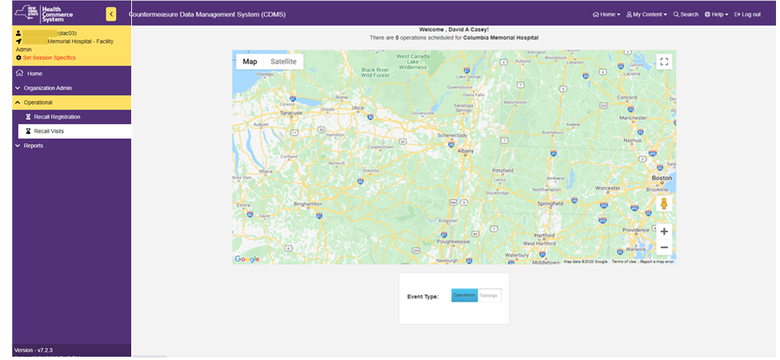

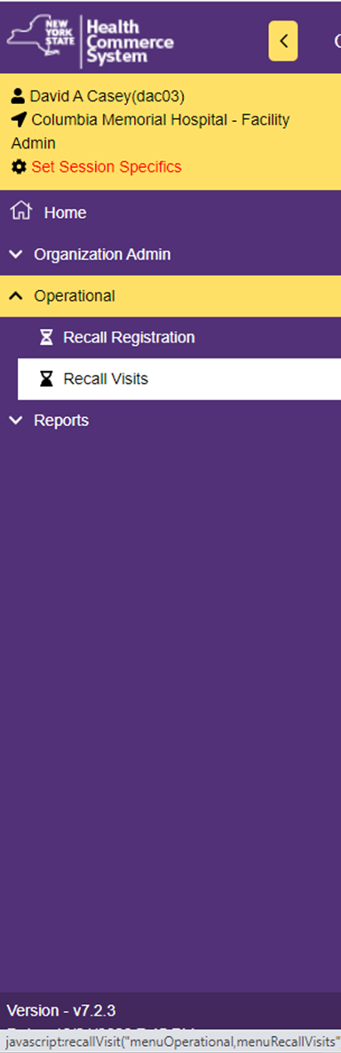
Instructions for Recalling Visits:

- From the Home screen, select the 'Operational' menu option and click on
'Recall Visits.'

- In the 'Set Session Specifics' screen, select the Event, the Form Name
and the name of the POD from the provided drop-down menus.
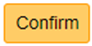
- Click on

Instructions for Recalling Visits:

- On the 'Recall Visit Search Results' screen, select the name of the registrant you wish to process.

- A ' Recall Visit' screen will appear that shows the record of the patient and includes demographic information including address, telephone number, date of birth, emergency contact information (if provided) and primary care provider (if provided).

- Verify patient's demographic information is correct.

Instructions for Recalling Visit:

- Scroll down to the 'Screening Questions' section and place your initials in the 'Screener Initials' box and select the appropriate option in the 'Screening Disposition' box (this will most likely be 'Referred for Countermeasure.'
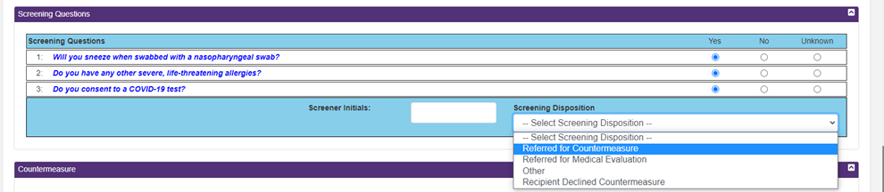

- Creating this record will confirm in CDMS that the patient came to the vaccination clinic (but does not confirm that the patient received a vaccination of any kind.
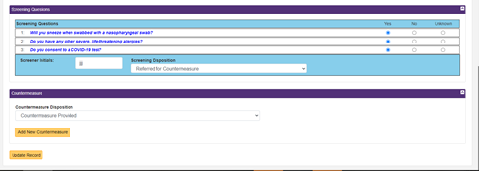

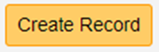
- Be sure to click on to save the record!

